***This is a bonus Web chapter

CHAPTER 47

2-4 Trees and B-Trees

Objectives
- To know what a 2-4 tree is (§47.1).
- To design the Tree24 class that implements the Tree interface (§47.2).
- To search an element in a 2-4 tree (§47.3).
- To insert an element in a 2-4 tree and know how to split a node (§47.4).
- To delete an element from a 2-4 tree and know how to perform transfer and fusion operations (§47.5).
- To traverse elements in a 2-4 tree (§47.6).
- To implement and test the Tree24 class (§§47.7-47.8).
- To analyze the complexity of the 2-4 tree (§47.9).
- To use B-trees for indexing large amount of data (§47.10).
47.1 Introduction
<margin note: completely balanced tree>
<margin note: 2-node>
<margin note: 3-node>
<margin note: 4-node>
A 2-4 tree, also known as a 2-3-4 tree, is a completely balanced search tree with all leaf nodes appearing on the same level. In a 2-4 tree, a node may have one, two, or three elements. An interior 2-node contains one element and two children. An interior 3-node contains two elements and three children. An interior 4-node contains three elements and four children, as shown in Figure 47.1.

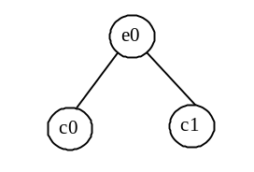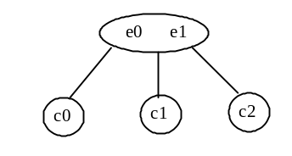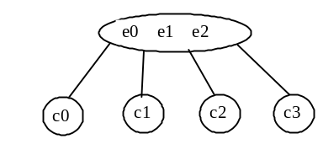

(a) 2-node (b) 3-node (c) 4-node

Figure 47.1
An interior node of a 2-4 tree has two, three, or four children.

<margin note: ordered>
Each child is a sub 2-4 tree, possibly empty. The root node has no parent, and leaf nodes have no children. The elements in the tree are distinct. The elements in a node are ordered such that

<margin note: E(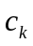)>
<margin note: left subtree>
<margin note: right subtree>
where E() denote the elements in . Figure 47.2 shows an example of a 2-4 tree. is called the left subtree of 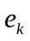 and 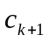 is called the right subtree of .

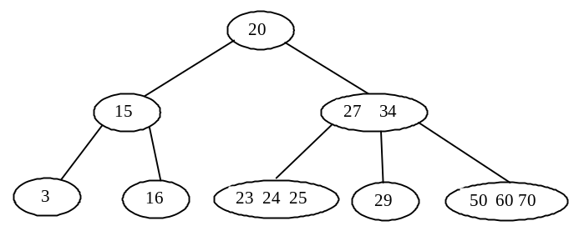

Figure 47.2
A 2-4 tree is a full complete search tree.

<margin note: binary vs. 2-4>
In a binary tree, each node contains one element. A 2-4 tree tends to be shorter than a corresponding binary search tree, since a 2-4 tree node may contain two or three elements.

Pedagogical NOTE
<side remark: 2-4 tree animation>
Run from www.cs.armstrong.edu/liang/animation/Tree24Animation.html to see how a 2-4 tree works, as shown in Figure 47.3.

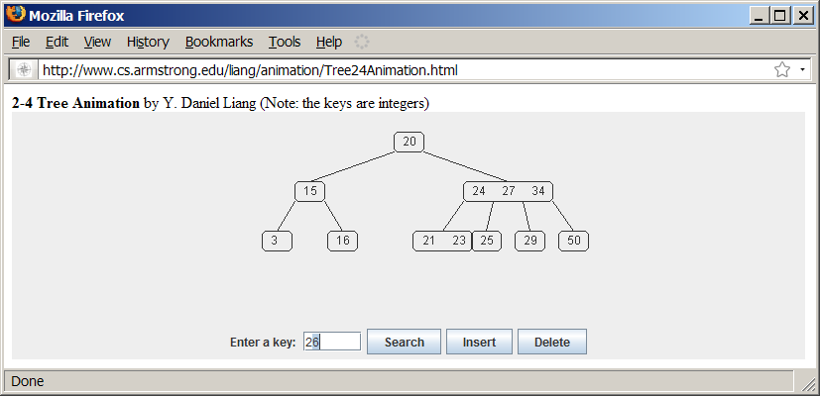

Figure 47.3

The animation tool enables you to insert, delete, and search elements in a 2-4 tree visually.
***End NOTE

47.2 Designing Classes for 2-4 Trees
The Tree24 class can be designed by implementing the Tree interface, as shown in Figure 47.4. The Tree interface was defined in Listing 27.3 Tree.java. The Tree24Node class defines tree nodes. The elements in the node are stored in a list named elements and the links to the child nodes are stored in a list named child, as shown in Figure 47.5.

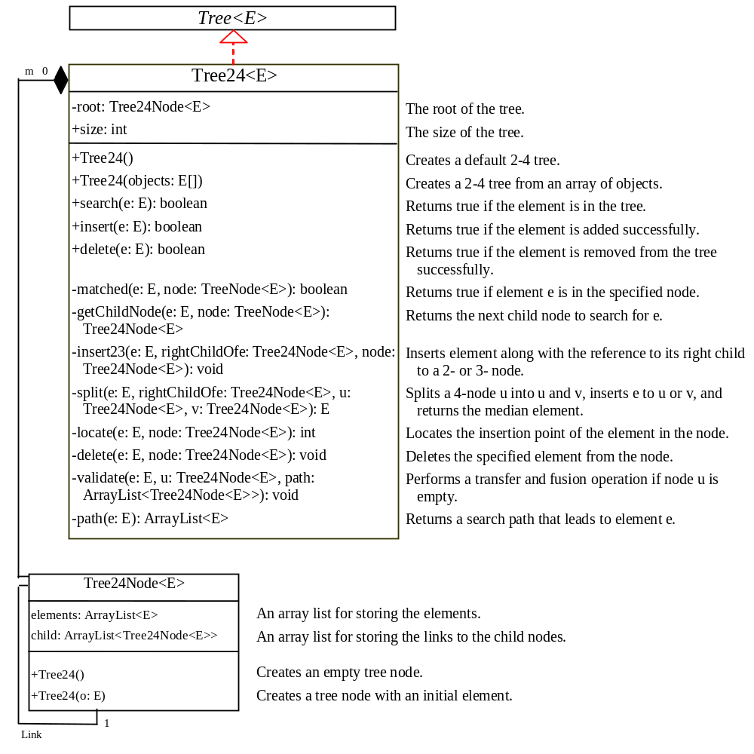

Figure 47.4
The Tree24 class implements Tree.

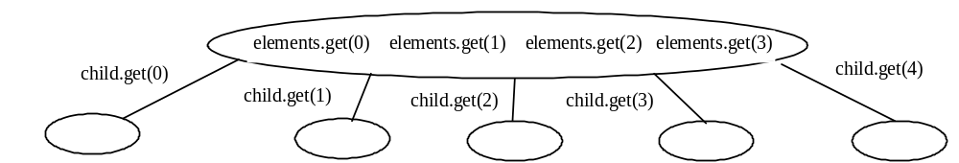

Figure 47.5
A 2-4 tree node stores the elements and the links to the child nodes in array lists.

47.3 Searching an Element
Searching an element in a 2-4 tree is similar to searching an element in a binary tree. The difference is that you have to search an element within a node in addition to searching elements along the path. To search an element in a 2-4 tree, you start from the root and scan down. If an element is not in the node, move to an appropriate subtree. Repeat the process until a match is found or you arrive at an empty subtree. The algorithm is described in Listing 47.1.

Listing 47.1 Searching an Element in a 2-4 Tree
<margin note line 2: start from root>
<margin note line 6: found>
<margin note line 9: search a subtree>
<margin note line 13: not found>

boolean search(E e) {
current = root; // Start from the root

while (current != null) {
if (match(e, current)) { // Element is in the node
return true; // Element is found
}
else {
current = getChildNode(e, current); // Search in a subtree
}
}

return false; // Element is not in the tree
}

The match(e, current) method checks whether element e is in the current node. The getChildNode(e, current) method returns the root of the subtree for further search. Initially, let current point to the root (line 2). Repeat searching the element in the current node until current is null (line 4) or the element matches an element in the current node.

47.4 Inserting an Element into a 2-4 Tree
<margin note: overflow>
<margin note: split>
To insert an element 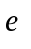to a 2-4 tree, locate a leaf node in which the element will be inserted. If the leaf node is a 2-node or 3-node, simply insert the element into the node. If the node is a 4-node, inserting a new element would cause an overflow. To resolve overflow, perform a split operation as follows:

- Let be the leaf 4-node in which the element will be inserted and 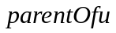 be the parent of , as shown in Figure 47.6(a).
- Create a new node named ; move 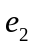 to .
- If 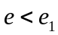, insert to ; otherwise insert to. Assume that 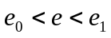, is inserted into , as shown in Figure 47.6(b).
- Insert along with its right child (i.e., ) to the parent node, as shown in Figure 47.6(b).

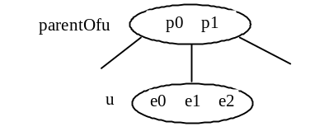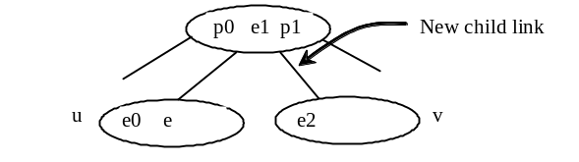
(a) Before inserting (b) After inserting

Figure 47.6
The splitting operation creates a new node and inserts the median element to its parent.

The parent node is a 3-node in Figure 47.6. So, there is room to insert to the parent node. What happens if it is a 4-node, as shown in Figure 47.7? This requires that the parent node be split. The process is the same as splitting a leaf 4-node, except that you must also insert the element along with its right child.

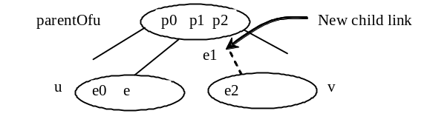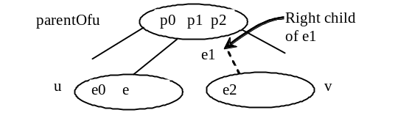
(a) The parent is a 4-node (b) Inserting 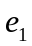 into the parent

Figure 47.7
Insertion process continues if the parent node is a 4-node.

The algorithm can be modified as follows:

- Let be the 4-node (leaf or nonleaf) in which the element will be inserted and be the parent of , as shown in Figure 47.8(a).
- Create a new node named , move and its children 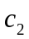 and 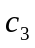 to .
- If , insert along with its right child link to ; otherwise insert along with its right child link to , as shown in Figure 47.6(b), (c), (d) for the cases , 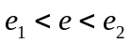, and 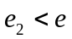, respectively.
- Insert along with its right child (i.e., ) to the parent node, recursively.

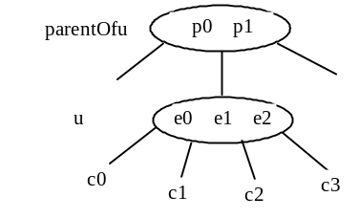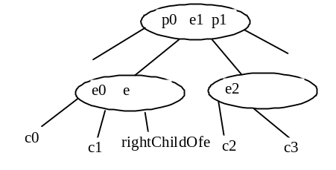
(a) Before inserting (b) After inserting ()

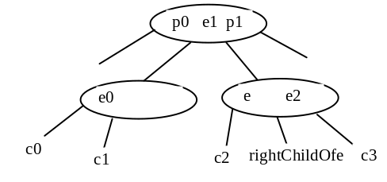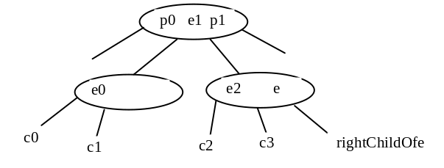
(c) After inserting () (d) After inserting ()

Figure 47.8
An interior node may be split to resolve overflow.

Listing 47.2 gives an algorithm for inserting an element.

Listing 47.2 Inserting an Element to a 2-4 Tree
<margin note line 3: create a new node>
<margin note line 5: search e>
<margin note line 6: insert e>
<margin note line 9: one element added>
<margin note line 10: element added>
<margin note line 13: insert to a node>
<margin note line 15: a 2- or 3- node>
<margin note line 20: split 4-node>
<margin note line 23: new root>
<margin note line 29: insert median to parent>

public boolean insert(E e) {
if (root == null)
root = new Tree24Node<E>(e); // Create a new root for element
else {
Locate leafNode for inserting e
insert(e, null, leafNode); // The right child of e is null
}

size++; // Increase size
return true; // Element inserted
}

private void insert(E e, Tree24Node<E> rightChildOfe,
Tree24Node<E> u) {
if (u is a 2- or 3- node) { // u is a 2- or 3-node
insert23(e, rightChildOfe, u); // Insert e to node u
}
else { // Split a 4-node u
Tree24Node<E> v = new Tree24Node<E>(); // Create a new node
E median = split(e, rightChildOfe, u, v); // Split u

if (u == root) { // u is the root
root = new Tree24Node<E>(median); // New root
root.child.add(u); // u is the left child of median
root.child.add(v); // v is the right child of median
}
else {
Get the parent of u, parentOfu;
insert(median, v, parentOfu); // Inserting median to parent
}
}
}

The insert(E e, Tree24Node<E> rightChildOfe, Tree24Node<E> u) method inserts element e along with its right child to node u. When inserting e to a leaf node, the right child of e is null (line 6). If the node is a 2- or 3-node, simply insert the element to the node (lines 15–17). If the node is a 4-node, invoke the split method to split the node (line 20). The split method returns the median element. Recursively invoke the insert method to insert the median element to the parent node (line 29). Figure 47.9 shows the steps of inserting elements 34, 3, 50, 20, 15, 16, 25, 27, 29, and 24 into a 2-4 tree.

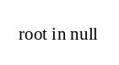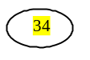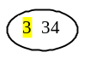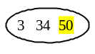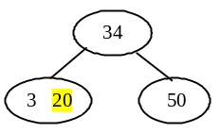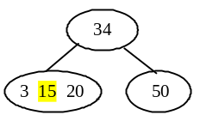

(a) (b) (c) (d) (e) (f)

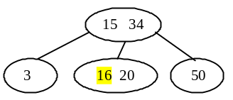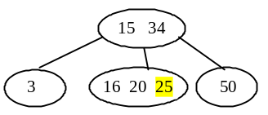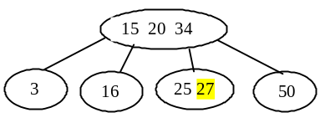
(g) (h) (i)

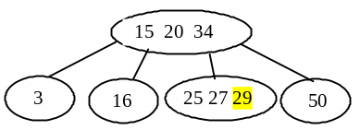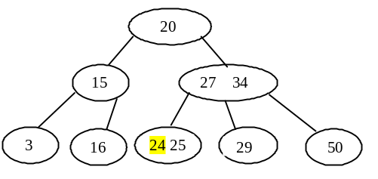
(j) (k)

Figure 47.9
The tree changes after 34, 3, 50, 20, 15, 16, 25, 27, 29, and 24 are added into an empty tree.

47.5 Deleting an Element from a 2-4 Tree
To delete an element from a 2-4 tree, first search the element in the tree to locate the node that contains it. If the element is not in the tree, the method returns false. Let be the node that contains the element and 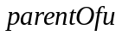 be the parent of . Consider three cases:

Case 1: is a leaf 3-node or 4-node. Delete from .

<margin note: underflow>
Case 2: is a leaf 2-node. Delete from . Now is empty. This situation is known as underflow. To remedy an underflow, consider two subcases:

<margin note: transfer>
Case 2.1: ’s immediate left or right sibling is a 3- or 4-node. Let the node be , as shown in Figure 47.10(a) (assume that is a left sibling of ). Perform a transfer operation that moves an element from to , as shown in Figure 47.10(b), and move an element from to replace the moved element in , as shown in Figure 47.10(c).

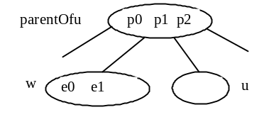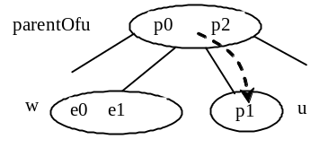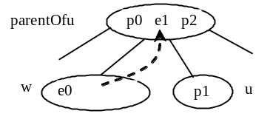
(a) is now empty (b) Move 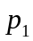 to (c) Move to replace

Figure 47.10
The transfer operation fills the empty node u.

<margin note: fusion>
Case 2.2: Both ’s immediate left and right sibling are 2-node if they exist ( may have only one sibling). Let the node be , as shown in Figure 47.11(a) (assume that is a left sibling of ). Perform a fusion operation that discards and moves an element from to , as shown in Figure 47.11(b). If becomes empty, repeat Case 2 recursively to perform a transfer or a fusion on .

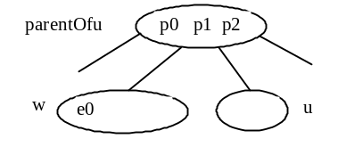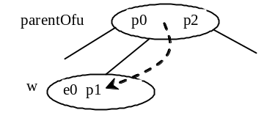
(a) is a 2-node (b) Move to

Figure 47.11
The fusion operation discards the empty node u.

<margin note: internal node>
Case 3: is a nonleaf node. Find the rightmost leaf node in the left subtree of . Let this node be , as shown in Figure 47.12(a). Move the last element in to replace in , as shown in Figure 47.12(b). If becomes empty, apply a transfer or fusion operation on .

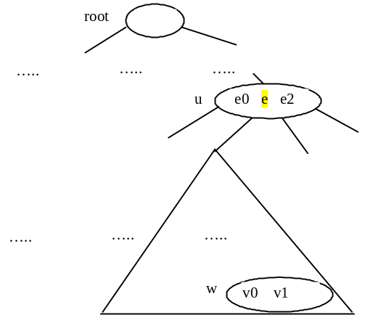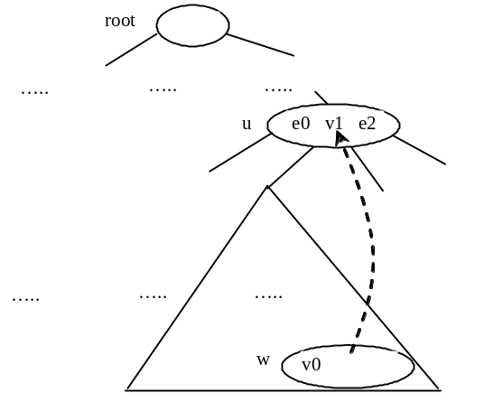
(a) is in (b) Replace with v1

Figure 47.12
An element in the internal node is replaced by an element in a leaf node.

Listing 47.3 describes the algorithm for deleting an element.

Listing 47.3 Deleting an Element from a 2-4 Tree
<margin note line 3: locate the node>
<margin note line 5: delete e>
<margin note line 10: element not found>
<margin note line 14: delete e>
<margin note line 19: delete e>
<margin note line 22: check and fix underflow>
<margin note line 25: locate rightmost element>
<margin note line 34: check and fix underflow>
<margin note line 39: check and fix underflow>

/** Delete the specified element from the tree */
public boolean delete(E e) {
Locate the node that contains the element e
if (the node is found) {
delete(e, node); // Delete element e from the node
size--; // After one element deleted
return true; // Element deleted successfully
}

return false; // Element not in the tree
}

/** Delete the specified element from the node */
private void delete(E e, Tree24Node<E> node) {
if (e is in a leaf node) {
// Get the path that leads to e from the root
ArrayList<Tree24Node<E>> path = path(e);

Remove e from the node;

// Check node for underflow along the path and fix it
validate(e, node, path); // Check underflow node
}
else { // e is in an internal node
Locate the rightmost node in the left subtree of node u;
Get the rightmost element from the rightmost node;

// Get the path that leads to e from the root
ArrayList<Tree24Node<E>> path = path(rightmostElement);

Replace the element in the node with the rightmost element

// Check node for underflow along the path and fix it
validate(rightmostElement, rightmostNode, path);
}
}

/** Perform a transfer or fusion operation if necessary */
private void validate(E e, Tree24Node<E> u,
ArrayList<Tree24Node<E>> path) {
for (int i = path.size() - 1; i >= 0; i--) {
if (u is not empty)
return; // Done, no need to perform transfer or fusion

Tree24Node<E> parentOfu = path.get(i - 1); // Get parent of u

// Check two siblings
if (left sibling of u has more than one element) {
Perform a transfer on u with its left sibling
}
else if (right sibling of u has more than one element) {
Perform a transfer on u with its right sibling
}
else if (u has left sibling) { // Fusion with a left sibling
Perform a fusion on u with its left sibling
u = parentOfu; // Back to the loop to check the parent node
}
else { // Fusion with right sibling (right sibling must exist)
Perform a fusion on u with its right sibling
u = parentOfu; // Back to the loop to check the parent node
}
}
}

The delete(E e) method locates the node that contains the element e and invokes the delete(E e, Tree24Node<E> node) method (line 5) to delete the element from the node.

If the node is a leaf node, get the path that leads to e from the root (line 17), delete e from the node (line 19), and invoke validate to check and fix the empty node (line 22). The validate(E e, Tree24Node<E> u, ArrayList<Tree24Node<E>> path) method performs a transfer or fusion operation if the node is empty. Since these operations may cause the parent of node u to become empty, a path is obtained in order to obtain the parents along the path from the root to node u, as shown in Figure 47.13.

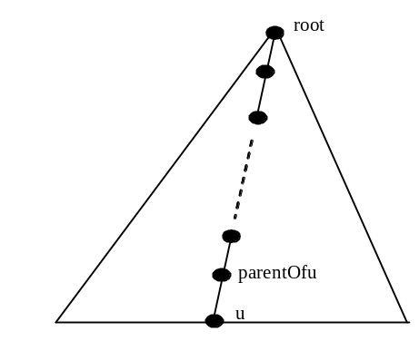

Figure 47.13
The nodes along the path may become empty as result of a transfer and fusion operation.

If the node is a nonleaf node, locate the rightmost element in the left subtree of the node (lines 25–26), get the path that leads to the rightmost element from the root (line 29), replace e in the node with the rightmost element (line 31), and invoke validate to fix the rightmost node if it is empty (line 34).

The validate(E e, Tree24Node<E> u, ArrayList<Tree24Node<E>> path) checks whether u is empty and performs a transfer or fusion operation to fix the empty node. The validate method exits when node is not empty (line 43). Otherwise, consider one of the following cases:

- If u has a left sibling with more than one element, perform a transfer on u with its left sibling (line 49).
- Otherwise, if u has a right sibling with more than one element, perform a transfer on u with its right sibling (line 52).
- Otherwise, if u has a left sibling, perform a fusion on u with its left sibling (line 55) and reset u to parentOfu (line 56).
- Otherwise, u must have a right sibling. Perform a fusion on u with its right sibling (line 59) and reset u to parentOfu (line 60).

Only one of the preceding cases is executed. Afterward, a new iteration starts to perform a transfer or fusion operation on a new node u if needed. Figure 47.14 shows the steps of deleting elements 20, 15, 3, 6, and 34 are deleted from a 2-4 tree in Figure 47.9(k).

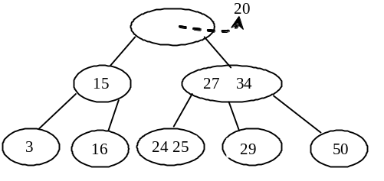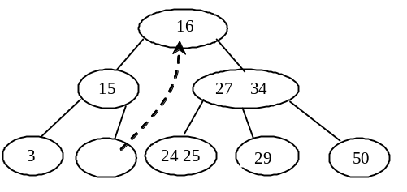
(a) Delete 20 (b) Replace 20 with 16

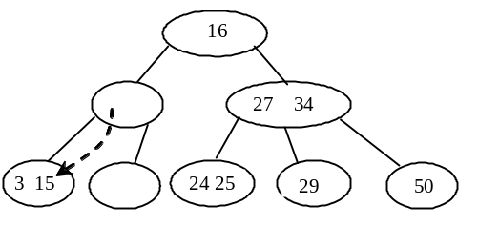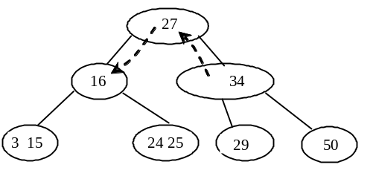
(c) Perform a fusion (d) Perform a transfer

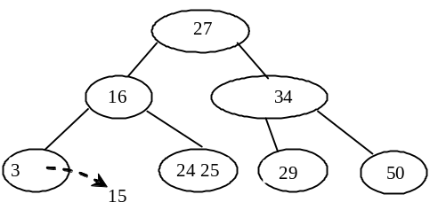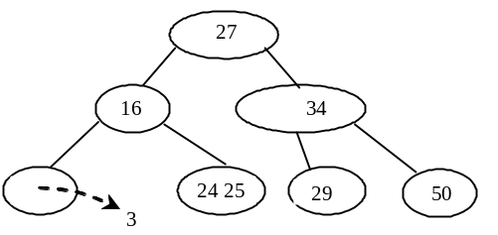

(e) Delete 15 (f) Delete 3

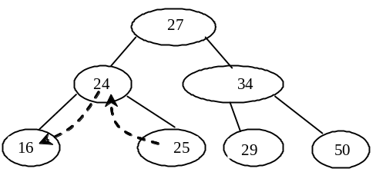 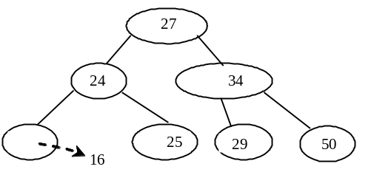
(g) Perform a transfer (h) Delete 16

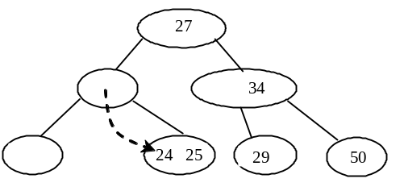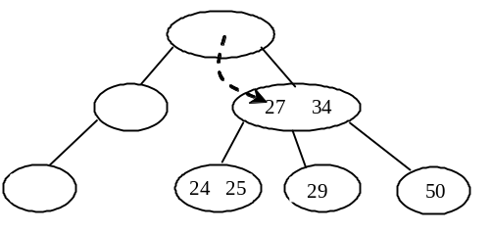
(i) Perform a fusion (j) Perform a fusion

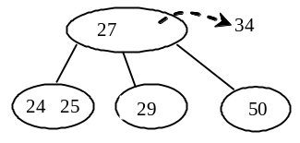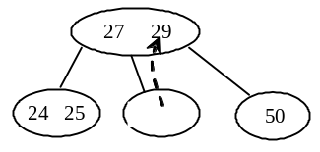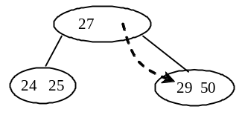
(k) Delete 34 (l) Replace 34 with 16 (m) Perform a fusion

Figure 47.14
The tree changes after 20, 15, 3, 6, and 34 are deleted from a 2-4 tree.

47.6 Traversing Elements in a 2-4 Tree
Inorder, preorder, and postorder traversals are useful for 2-4 trees. Inorder traversal visits the elements in increasing order. Preorder traversal visits the elements in the root, then recursively visits the subtrees from the left to right. Postorder traversal visits the subtrees from the left to right recursively, and then the elements in the root.

For example, in the 2-4 tree in Figure 47.9(k), the inorder traversal is

3 15 16 20 24 25 27 29 34 50

The preorder traversal is

20 15 3 16 27 34 24 25 29 50

The postorder traversal is

3 16 1 24 25 29 50 27 34 20

47.7 Implementing the Tree24 Class
Listing 47.4 gives the complete source code for the Tree24 class.

Listing 47.4 Tree24.java
<margin note line 4: root>
<margin note line 5: size>
<margin note line 8: no-arg constructor>
<margin note line 12: constructor>
<margin note line 18: search>
<margin note line 22: found?>
<margin note line 26: next subtree>
<margin note line 34: find a match>
<margin note line 36: matched?>
<margin note line 43: next subtree>
<margin note line 44: leaf node?>
<margin note line 47: insertion point>
<margin note line 54: insert to tree>
<margin note line 55: empty tree?>
<margin note line 59: find leaf node>
<margin note line 71: insert to node>
<margin note line 79: insert to node>
<margin note line 85: no overflow>
<margin note line 90: overflow>
<margin note line 91: split>
<margin note line 93: u is root?>
<margin note line 101: insert to parentOfu>
<margin note line 110: insert to node>
<margin note line 112: insertion point>
<margin note line 119: split>
<margin note line 123: get median>
<margin note line 127: insert e>
<margin note line 133: insert rightChildOfe>
<margin note line 138: return median>
<margin note line 142: get path>
<margin note line 147: add node searched>
<margin note line 156: return path>
<margin note line 160: delete from tree>
<margin note line 162: locate the node>
<margin note line 164: found?>
<margin note line 165: delete from node>
<margin note line 177: delete from node>
<margin note line 178: leaf node?>
<margin note line 182: delete e>
<margin note line 184: node is root?>
<margin note line 190: validate tree>
<margin note line 192: nonleaf node>
<margin note line 194: rightmost element>
<margin note line 206: replace element>
<margin note line 209: validate tree>
<margin note line 214: validate tree>
<margin note line 222: transfer with left sibling>
<margin note line 226: transfer with right sibling>
<margin note line 233: fusion with left sibling>
<margin note line 248: fusion with right sibling>
<margin note line 262: locate insertion point>
<margin note line 273: transfer with left sibling>
<margin note line 290: transfer with right sibling>
<margin note line 305: fusion with left sibling>
<margin note line 319: fusion with right sibling>
<margin note line 338: preorder>
<margin note line 343: recursive preorder>
<margin note line 343: recursive preorder>

<margin note line 374: inner Tree24Node class>
<margin note line 376: element list>
<margin note line 378: child list>

import java.util.ArrayList;

public class Tree24<E extends Comparable<E>> implements Tree<E> {
private Tree24Node<E> root;
private int size;

/** Create a default 2-4 tree */
public Tree24() {
}

/** Create a 2-4 tree from an array of objects */
public Tree24(E[] elements) {
for (int i = 0; i < elements.length; i++)
insert(elements[i]);
}

/** Search an element in the tree */
public boolean search(E e) {
Tree24Node<E> current = root; // Start from the root

while (current != null) {
if (matched(e, current)) { // Element is in the node
return true; // Element found
}
else {
current = getChildNode(e, current); // Search in a subtree
}
}

return false; // Element is not in the tree
}

/** Return true if the element is found in this node */
private boolean matched(E e, Tree24Node<E> node) {
for (int i = 0; i < node.elements.size(); i++)
if (node.elements.get(i).equals(e))
return true; // Element found

return false; // No match in this node
}

/** Locate a child node to search element e */
private Tree24Node<E> getChildNode(E e, Tree24Node<E> node) {
if (node.child.size() == 0)
return null; // node is a leaf

int i = locate(e, node); // Locate the insertion point for e
return node.child.get(i); // Return the child node
}

/** Insert element e into the tree
* Return true if the element is inserted successfully
*/
public boolean insert(E e) {
if (root == null)
root = new Tree24Node<E>(e); // Create a new root for element
else {
// Locate the leaf node for inserting e
Tree24Node<E> leafNode = null;
Tree24Node<E> current = root;
while (current != null)
if (matched(e, current)) {
return false; // Duplicate element found, nothing inserted
}
else {
leafNode = current;
current = getChildNode(e, current);
}

// Insert the element e into the leaf node
insert(e, null, leafNode); // The right child of e is null
}

size++; // Increase size
return true; // Element inserted
}

/** Insert element e into node u */
private void insert(E e, Tree24Node<E> rightChildOfe,
Tree24Node<E> u) {
// Get the search path that leads to element e
ArrayList<Tree24Node<E>> path = path(e);

for (int i = path.size() - 1; i >= 0; i--) {
if (u.elements.size() < 3) { // u is a 2-node or 3-node
insert23(e, rightChildOfe, u); // Insert e to node u
break; // No further insertion to u's parent needed
}
else {
Tree24Node<E> v = new Tree24Node<E>(); // Create a new node
E median = split(e, rightChildOfe, u, v); // Split u

if (u == root) {
root = new Tree24Node<E>(median); // New root
root.child.add(u); // u is the left child of median
root.child.add(v); // v is the right child of median
break; // No further insertion to u's parent needed
}
else {
// Use new values for the next iteration in the for loop
e = median; // Element to be inserted to parent
rightChildOfe = v; // Right child of the element
u = path.get(i - 1); // New node to insert element
}
}
}
}

/** Insert element to a 2- or 3- and return the insertion point */
private void insert23(E e, Tree24Node<E> rightChildOfe,
Tree24Node<E> node) {
int i = this.locate(e, node); // Locate where to insert
node.elements.add(i, e); // Insert the element into the node
if (rightChildOfe != null)
node.child.add(i + 1, rightChildOfe); // Insert the child link
}

/** Split a 4-node u into u and v and insert e to u or v */
private E split(E e, Tree24Node<E> rightChildOfe,
Tree24Node<E> u, Tree24Node<E> v) {
// Move the last element in node u to node v
v.elements.add(u.elements.remove(2));
E median = u.elements.remove(1);

// Split children for a nonleaf node
// Move the last two children in node u to node v
if (u.child.size() > 0) {
v.child.add(u.child.remove(2));
v.child.add(u.child.remove(2));
}

// Insert e into a 2- or 3- node u or v.
if (e.compareTo(median) < 0)
insert23(e, rightChildOfe, u);
else
insert23(e, rightChildOfe, v);

return median; // Return the median element
}

/** Return a search path that leads to element e */
private ArrayList<Tree24Node<E>> path(E e) {
ArrayList<Tree24Node<E>> list = new ArrayList<Tree24Node<E>>();
Tree24Node<E> current = root; // Start from the root

while (current != null) {
list.add(current); // Add the node to the list
if (matched(e, current)) {
break; // Element found
}
else {
current = getChildNode(e, current);
}
}

return list; // Return an array of nodes
}

/** Delete the specified element from the tree */
public boolean delete(E e) {
// Locate the node that contains the element e
Tree24Node<E> node = root;
while (node != null)
if (matched(e, node)) {
delete(e, node); // Delete element e from node
size--; // After one element deleted
return true; // Element deleted successfully
}
else {
node = getChildNode(e, node);
}

return false; // Element not in the tree
}

/** Delete the specified element from the node */
private void delete(E e, Tree24Node<E> node) {
if (node.child.size() == 0) { // e is in a leaf node
// Get the path that leads to e from the root
ArrayList<Tree24Node<E>> path = path(e);

node.elements.remove(e); // Remove element e

if (node == root) { // Special case
if (node.elements.size() == 0)
root = null; // Empty tree
return; // Done
}

validate(e, node, path); // Check underflow node
}
else { // e is in an internal node
// Locate the rightmost node in the left subtree of the node
int index = locate(e, node); // Index of e in node
Tree24Node<E> current = node.child.get(index);
while (current.child.size() > 0) {
current = current.child.get(current.child.size() - 1);
}
E rightmostElement =
current.elements.get(current.elements.size() - 1);

// Get the path that leads to e from the root
ArrayList<Tree24Node<E>> path = path(rightmostElement);

// Replace the deleted element with the rightmost element
node.elements.set(index, current.elements.remove(
current.elements.size() - 1));

validate(rightmostElement, current, path); // Check underflow
}
}

/** Perform transfer and confusion operations if necessary */
private void validate(E e, Tree24Node<E> u,
ArrayList<Tree24Node<E>> path) {
for (int i = path.size() - 1; u.elements.size() == 0; i--) {
Tree24Node<E> parentOfu = path.get(i - 1); // Get parent of u
int k = locate(e, parentOfu); // Index of e in the parent node

// Check two siblings
if (k > 0 && parentOfu.child.get(k - 1).elements.size() > 1) {
leftSiblingTransfer(k, u, parentOfu);
}
else if (k + 1 < parentOfu.child.size() &&
parentOfu.child.get(k + 1).elements.size() > 1) {
rightSiblingTransfer(k, u, parentOfu);
}
else if (k - 1 >= 0) { // Fusion with a left sibling
// Get left sibling of node u
Tree24Node<E> leftNode = parentOfu.child.get(k - 1);

// Perform a fusion with left sibling on node u
leftSiblingFusion(k, leftNode, u, parentOfu);

// Done when root becomes empty
if (parentOfu == root && parentOfu.elements.size() == 0) {
root = leftNode;
break;
}

u = parentOfu; // Back to the loop to check the parent node
}
else { // Fusion with right sibling (right sibling must exist)
// Get left sibling of node u
Tree24Node<E> rightNode = parentOfu.child.get(k + 1);

// Perform a fusion with right sibling on node u
rightSiblingFusion(k, rightNode, u, parentOfu);

// Done when root becomes empty
if (parentOfu == root && parentOfu.elements.size() == 0) {
root = rightNode;
break;
}

u = parentOfu; // Back to the loop to check the parent node
}
}
}

/** Locate the insertion point of the element in the node */
private int locate(E o, Tree24Node<E> node) {
for (int i = 0; i < node.elements.size(); i++) {
if (o.compareTo(node.elements.get(i)) <= 0) {
return i;
}
}

return node.elements.size();
}

/** Perform a transfer with a left sibling */
private void leftSiblingTransfer(int k,
Tree24Node<E> u, Tree24Node<E> parentOfu) {
// Move an element from the parent to u
u.elements.add(0, parentOfu.elements.get(k - 1));

// Move an element from the left node to the parent
Tree24Node<E> leftNode = parentOfu.child.get(k - 1);
parentOfu.elements.set(k - 1,
leftNode.elements.remove(leftNode.elements.size() - 1));

// Move the child link from left sibling to the node
if (leftNode.child.size() > 0)
u.child.add(0, leftNode.child.remove(
leftNode.child.size() - 1));
}

/** Perform a transfer with a right sibling */
private void rightSiblingTransfer(int k,
Tree24Node<E> u, Tree24Node<E> parentOfu) {
// Transfer an element from the parent to u
u.elements.add(parentOfu.elements.get(k));

// Transfer an element from the right node to the parent
Tree24Node<E> rightNode = parentOfu.child.get(k + 1);
parentOfu.elements.set(k, rightNode.elements.remove(0));

// Move the child link from right sibling to the node
if (rightNode.child.size() > 0)
u.child.add(rightNode.child.remove(0));
}

/** Perform a fusion with a left sibling */
private void leftSiblingFusion(int k, Tree24Node<E> leftNode,
Tree24Node<E> u, Tree24Node<E> parentOfu) {
// Transfer an element from the parent to the left sibling
leftNode.elements.add(parentOfu.elements.remove(k - 1));

// Remove the link to the empty node
parentOfu.child.remove(k);

// Adjust child links for nonleaf node
if (u.child.size() > 0)
leftNode.child.add(u.child.remove(0));
}

/** Perform a fusion with a right sibling */
private void rightSiblingFusion(int k, Tree24Node<E> rightNode,
Tree24Node<E> u, Tree24Node<E> parentOfu) {
// Transfer an element from the parent to the right sibling
rightNode.elements.add(0, parentOfu.elements.remove(k));

// Remove the link to the empty node
parentOfu.child.remove(k);

// Adjust child links for nonleaf node
if (u.child.size() > 0)
rightNode.child.add(0, u.child.remove(0));
}

/** Get the number of nodes in the tree */
public int getSize() {
return size;
}

/** Preorder traversal from the root */
public void preorder() {
preorder(root);
}

/** Preorder traversal from a subtree */
private void preorder(Tree24Node<E> root) {
if (root == null)return;
for (int i = 0; i < root.elements.size(); i++)
System.out.print(root.elements.get(i) + " ");

for (int i = 0; i < root.child.size(); i++)
preorder(root.child.get(i));
}

/** Inorder traversal from the root*/
public void inorder() {
// Left as exercise
}

/** Postorder traversal from the root */
public void postorder() {
// Left as exercise
}

/** Return true if the tree is empty */
public boolean isEmpty() {
return root == null;
}

/** Return an iterator to traverse elements in the tree */
public java.util.Iterator iterator() {
// Left as exercise
return null;
}

/** Define a 2-4 tree node */
protected static class Tree24Node<E extends Comparable<E>> {
// elements has maximum three values
ArrayList<E> elements = new ArrayList<E>(3);
// Each has maximum four childres
ArrayList<Tree24Node<E>> child
= new ArrayList<Tree24Node<E>>(4);

/** Create an empty Tree24 node */
Tree24Node() {
}

/** Create a Tree24 node with an initial element */
Tree24Node(E o) {
elements.add(o);
}
}
}

<margin note: root>
<margin note: size>
The Tree24 class contains the data fields root and size (lines 4–5). root references the root node and size stores the number of elements in the tree.

<margin note: constructors>
The Tree24 class has two constructors: a no-arg constructor (lines 8–9) that constructs an empty tree and a constructor that creates an initial Tree24 from an array of elements (lines 12–15).

<margin note: search>
The search method (lines 18–31) searches an element in the tree. It returns true (line 23) if the element is in the tree and returns false if the search arrives at an empty subtree (line 30).

<margin note: matched>
The matched(e, node) method (lines 34–40) checks where the element e is in the node.

<margin note: getChildNode>
The getChildNode(e, node) method (lines 43–49) returns the root of a subtree where e should be searched.

<margin note: insert(e)>
The insert(E e) method inserts an element in a tree (lines 54–78). If the tree is empty, a new root is created (line 56). The method locates a leaf node in which the element will be inserted and invokes insert(e, null, leafNode) to insert the element (line 71).

<margin note: insert(e, rightChildOfe, u)>
The insert(e, rightChildOfe, u) method inserts an element into node u (lines 79–107). The method first invokes path(e) (line 82) to obtain a search path from the root to node u. Each iteration of the for loop considers u and its parent parentOfu (lines 84–106). If u is a 2-node or 3-node, invoke insert23(e, rightChildOfe, u) to insert e and its child link rightChildOfe into u (line 86). No split is needed (line 87). Otherwise, create a new node v (line 90) and invoke split(e, rightChildOfe, u, v) (line 91) to split u into u and v. The split method inserts e into either u and v and returns the median in the original u. If u is the root, create a new root to hold median, and set u and v as the left and right children for median (lines 95–96). If u is not the root, insert median to parentOfu in the next iteration (lines 101–103).

<margin note: insert23>
The insert23(e, rightChildOfe, node) method inserts e along with the reference to its right child into the node (lines 110–116). The method first invokes locate(e, node) (line 112) to locate an insertion point, then insert e into the node (line 113). If rightChildOfe is not null, it is inserted into the child list of the node (line 115).

<margin note: split>
The split(e, rightChildOfe, u, v) method splits a 4-node u (lines 119-139). This is accomplished as follows: (1) move the last element from u to v and remove the median element from u (lines 122–123); (2) move the last two child links from u to v (lines 127–130) if u is a nonleaf node; (3) if e < median, insert e into u; otherwise, insert e into v (lines 133–136); (4) return median (line 138).

<margin note: path>
The path(e) method returns an ArrayList of nodes searched from the root in order to locate e (lines 142–157). If e is in the tree, the last node in the path contains e. Otherwise the last node is where e should be inserted.

<margin note: delete(e)>
The delete(E e) method deletes an element from the tree (lines 160–174). The method first locates the node that contains e and invokes delete(e, node) to delete e from the node (line 165). If the element is not in the tree, return false (line 173).

<margin note: delete(e, node)>
The delete(e, node) method deletes an element from node u (lines 177–211). If the node is a leaf node, obtain the path that leads to e (line 180), delete e (line 182), set root to null if the tree becomes empty (lines 184-188), and invoke validate to apply transfer and fusion operation on empty nodes (line 190). If the node is a nonleaf node, locate the rightmost element (lines 194–200), obtain the path that leads to e (line 203), replace e with the rightmost element (lines 206–207), and invoke validate to apply transfer and fusion operations on empty nodes (line 209).

<margin note: validate>
The validate(e, u, path) method ensures that the tree is a valid 2-4 tree (lines 214–259). The for loop terminates when u is not empty (line 216). The loop body is executed to fix the empty node u by performing a transfer or fusion operation. If a left sibling with more than one element exists, perform a transfer on u with the left sibling (line 222). Otherwise, if a right sibling with more than one element exists, perform a transfer on u with the left sibling (line 226). Otherwise, if a left sibling exists, perform a fusion on u with the left sibling (lines 230–239), and validate parentOfu in the next loop iteration (line 241). Otherwise, perform a fusion on u with the right sibling.

<margin note: locate>
The locate(e, node) method locates the index of e in the node (lines 262-270).

<margin note: transfer>
<margin note: fusion>
The leftSiblingTransfer(k, u, parentOfu) method performs a transfer on u with its left sibling (lines 273–287). The rightSiblingTransfer(k, u, parentOfu) method performs a transfer on u with its right sibling (lines 290–302). The leftSiblingFusion(k, leftNode, u, parentOfu) method performs a fusion on u with its left sibling leftNode (lines 305–316). The rightSiblingFusion(k, rightNode, u, parentOfu) method performs a fusion on u with its right sibling rightNode (lines 319–330).

<margin note: preorder>
The preorder() method displays all the elements in the tree in preorder (lines 338–350).

<margin note: Tree24Node>
The inner class Tree24Node defines a class for a node in the tree (lines 374–389).

47.8 Testing the Tree24 Class
Listing 47.5 gives a test program. The program creates a 2-4 tree and inserts elements in lines 6–20, and deletes elements in lines 22–56.

Listing 47.5 TestTree24.java
<margin note line 4: create a Tree24>
<margin note line 6: insert 34>
<margin note line 7: insert 3>
<margin note line 8: insert 50>
<margin note line 15: insert 24>
<margin note line 21: insert 70>
<margin note line 25: delete 34>

1 public class TestTree24 {
2 public static void main(String[] args) {
3 // Create a 2-4 tree
4 Tree24<Integer> tree = new Tree24<Integer>();
5
6 tree.insert(34);
7 tree.insert(3);
8 tree.insert(50);
9 tree.insert(20);
10 tree.insert(15);
11 tree.insert(16);
12 tree.insert(25);
13 tree.insert(27);
14 tree.insert(29);
15 tree.insert(24);
16 System.out.print("\nAfter inserting 24:");
17 printTree(tree);
18 tree.insert(23);
19 tree.insert(22);
20 tree.insert(60);
21 tree.insert(70);
22 System.out.print("\nAfter inserting 70:");
23 printTree(tree);
24
25 tree.delete(34);
26 System.out.print("\nAfter deleting 34:");
27 printTree(tree);
28
29 tree.delete(25);
30 System.out.print("\nAfter deleting 25:");
31 printTree(tree);
32
33 tree.delete(50);
34 System.out.print("\nAfter deleting 50:");
35 printTree(tree);
36
37 tree.delete(16);
38 System.out.print("\nAfter deleting 16:");
39 printTree(tree);
40
41 tree.delete(3);
42 System.out.print("\nAfter deleting 3:");
43 printTree(tree);
44
45 tree.delete(15);
46 System.out.print("\nAfter deleting 15:");
47 printTree(tree);
48 }
49
50 public static void printTree(Tree tree) {
51 // Traverse tree
52 System.out.print("\nPreorder: ");
53 tree.preorder();
54 System.out.print("\nThe number of nodes is " + tree.getSize());
55 System.out.println();
56 }
57 }

<Output>
After inserting 24:
Preorder: 20 15 3 16 27 34 24 25 29 50
The number of nodes is 10

After inserting 70:
Preorder: 20 15 3 16 24 27 34 22 23 25 29 50 60 70
The number of nodes is 14

After deleting 34:
Preorder: 20 15 3 16 24 27 50 22 23 25 29 60 70
The number of nodes is 13

After deleting 25:
Preorder: 20 15 3 16 23 27 50 22 24 29 60 70
The number of nodes is 12

After deleting 50:
Preorder: 20 15 3 16 23 27 60 22 24 29 70
The number of nodes is 11

After deleting 16:
Preorder: 23 20 3 15 22 27 60 24 29 70
The number of nodes is 10

After deleting 3:
Preorder: 23 20 15 22 27 60 24 29 70
The number of nodes is 9

After deleting 15:
Preorder: 27 23 20 22 24 60 29 70
The number of nodes is 8
<End Output>

Figure 47.15 shows how the tree evolves as elements are added. After 34, 3, 50, 20, 15, 16, 25, 27, 29, and 24 are added to the tree, it is as shown in Figure 47.15(a). After inserting 23, 22, 60, and 70, the tree is as shown in Figure 47.15(b). After inserting 23, 22, 60, and 70, the tree is as shown in Figure 47.15(b). After deleting 34, the tree is as shown in Figure 47.15(c). After deleting 25, the tree is as shown in Figure 47.15(d). After deleting 50, the tree is as shown in Figure 47.15(e). After deleting 16, the tree is as shown in Figure 47.15(f). After deleting 3, the tree is as shown in Figure 47.15(g). After deleting 15, the tree is as shown in Figure 47.15(h).

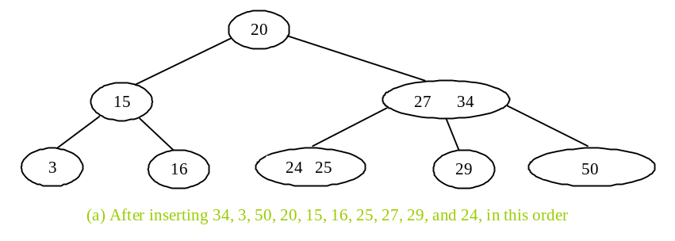

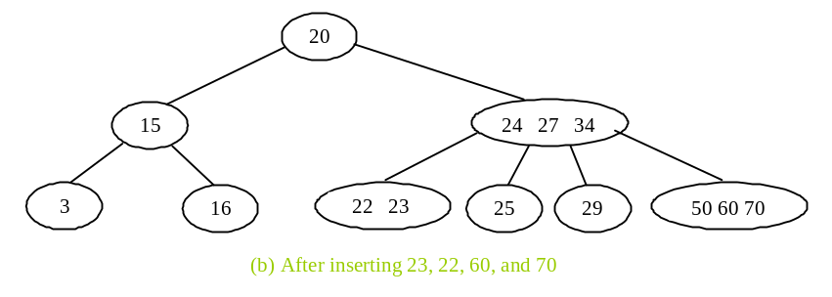

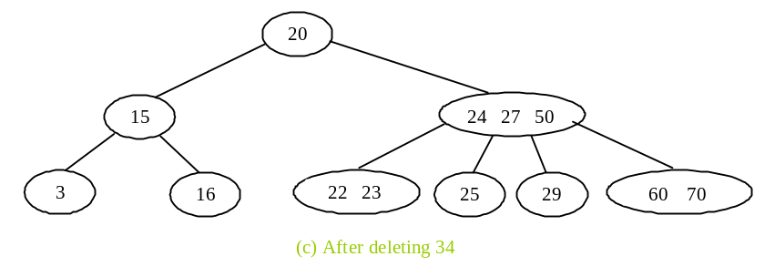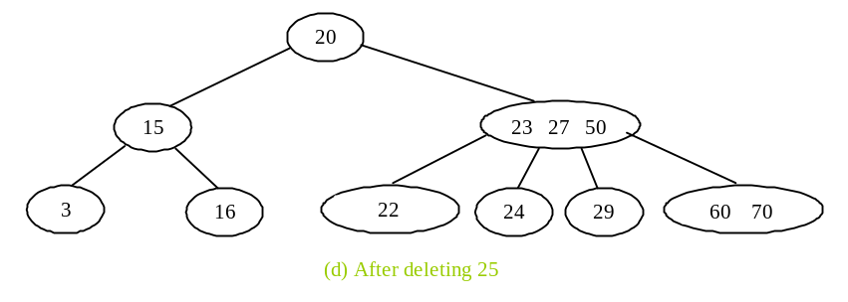
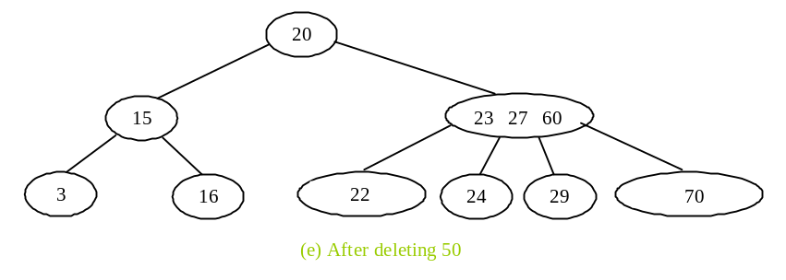
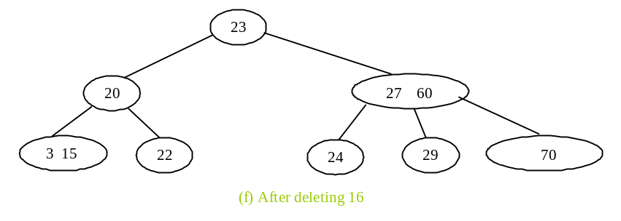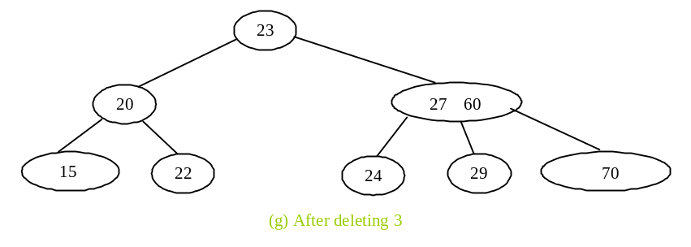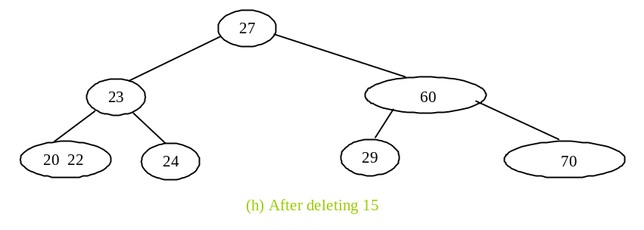

Figure 47.15
The tree evolves as elements are inserted and deleted.

47.9 Time-Complexity Analysis
Since a 2-4 tree is a completely balanced binary tree, its height is at most 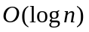. The search, insert, and delete methods operate on the nodes along a path in the tree. It takes a constant time to search an element within a node. So, the search method takes time. For the insert method, the time for splitting a node takes a constant time. So, the insert method takes time. For the delete method, it takes a constant time to perform a transfer and fusion operation. So, the delete method takes time.

47.10 B-Tree
So far we assume that the entire data set is stored in main memory. What if the data set is too large and cannot fit in the main memory, as in the case with most databases where data is stored on disks? Suppose you use an AVL tree to organize a million records in a database table. To find a record, the average number of nodes traversed is 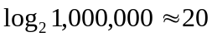. This is fine if all nodes are stored in main memory. However, for nodes stored on a disk, this means 20 disk reads. Disk I/O is expensive, and it is thousands of times slower than memory access. To improve performance, we need to reduce the number of disk I/Os. An efficient data structure for performing search, insertion, and deletion for data stored on secondary storage such as hard disks is the B-tree, which is a generalization of the 2-4 tree.

A B-tree of order is defined as follows:

- Each node except the root contains between 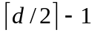 and 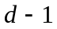 keys.
- The root may contain up to keys.
- A nonleaf node with keys has 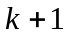 children.
- All leaf nodes have the same depth.
Figure 47.16 shows a B-tree of order 6. For simplicity, we use integers to represent keys. Each key is associated with a pointer that points to the actual record in the database. For simplicity, the pointers to the records in the database are omitted in the figure.

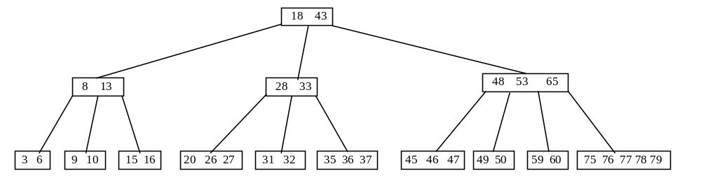 Figure 47.16
In a B-tree of order 6, each node except the root may contain between 2 and 5 keys.

Note that a B-tree is a search tree. The keys in each node are placed in increasing order. Each key in an interior node has a left subtree and a right subtree, as shown in Figure 47.17. All keys in the left subtree are less than the key in the parent node, and all keys in the right subtree are greater than the key in the parent node.

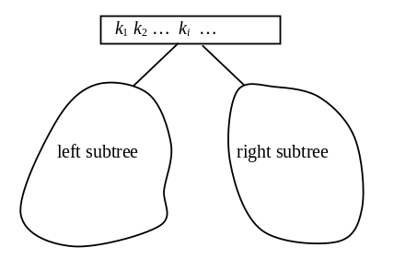

Figure 47.17
The keys in the left (right) subtree of key k_{i} are less than (greater than) k_{i}.

<margin note: one block per node>
The basic unit of the IO operations on a disk is a block. When you read data from a disk, the whole block that contains the data is read. You should choose an appropriate order so that a node can fit in a single disk block. This will minimize the number of disk IOs.

A 2-4 tree is actually a B-tree of order 4. The techniques for insertion and deletion in a 2-4 tree can be easily generalized for a B-tree.

<margin note: insertion>
Inserting a key to a B-tree is similar to what was done for a 2-4 tree. First locate the leaf node in which the key will be inserted. Insert the key to the node. After the insertion, if the leaf node has keys, an overflow occurs. To resolve overflow, perform a split operation similar to the one used in a 2-4 tree, as follows:

Let denote the node needed to be split and let m denote the median key in the node. Create a new node and move all keys greater than m to this new node. Insert m to the parent node of . Now u becomes the left child of m and v becomes the right child of m, as shown in Figure 47.18. If inserting m into the parent node of u causes an overflow, repeat the same split process on the parent node.

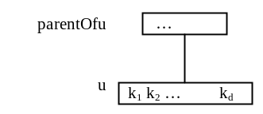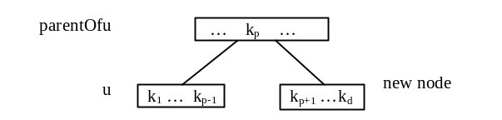

Figure 47.18
(a) After inserting a new key to node u. (b) The median key k_{p} is inserted to parentOfu.

<margin note: deletion>
A key can be deleted from a B-tree in the same way as in a 2-4 tree. First locate the node that contains the key. Consider two cases:

Case 1: If is a leaf node, remove the key from . After the removal, if has less than keys, an underflow occurs. To remedy an underflow, perform a transfer with a sibling of that has more than keys if such sibling exists, as shown in Figure 47.19. Otherwise perform a fusion with a sibling of , as shown in Figure 47.20.

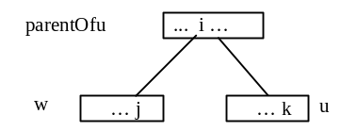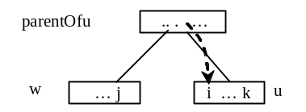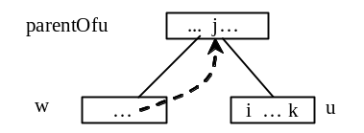
(a) Before a transfer is performed (b) Key i moved to node u (c) Key j moved to parentOfu

Figure 47.19
The transfer operation transfers a key from the parentOf to and transfers a key from ’s sibling parentOfu.

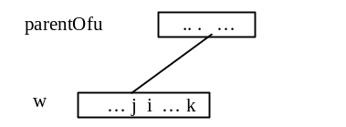
(a) Before a fusion is performed (b) After a fusion is performed

Figure 47.20
The fusion operation moves key i from the parentOfu to and moves all keys in to .

Case 2: is a nonleaf node. Find the rightmost leaf node in the left subtree of . Let this node be , as shown in Figure 47.21(a). Move the last key in to replace in , as shown in Figure 47.21(b). If becomes underflow, apply a transfer or fusion operation on .

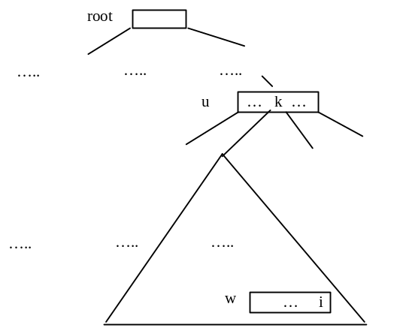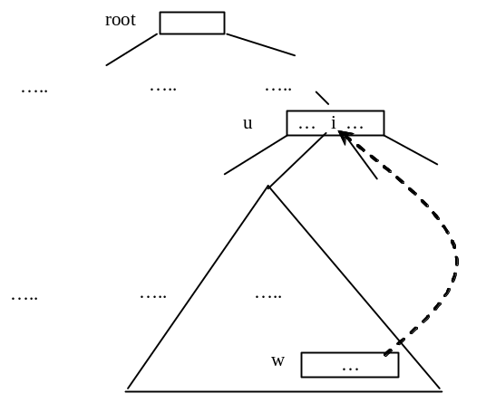
(a) Key is in (b) Replace key k with key i

Figure 47.21
A key in the internal node is replaced by an element in a leaf node.

<margin note: B-tree performance>
The performance of a B-tree depends on the number of disk IOs (i.e., the number of nodes accessed). The number of nodes accessed for search, insertion, and deletion operations depends on the height of the tree. In the worst case, each node contains keys. So, the height of the tree is 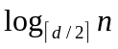, where is the number of keys. In the best case, each node contains keys. So, the height of the tree is 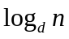. Consider a B-tree of order 12 for ten million keys. The height of the tree is between 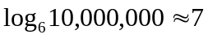 and 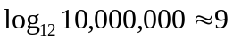. So, for search, insertion, and deletion operations, the maximum number of nodes visited is 47. If you use an AVL tree, the maximum number of nodes visited is 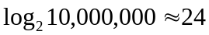.

Key Terms

- 2-3-4 tree
- 2-4 tree
- 2-node
- 3-node
- 4-node
- B-tree
- fusion operation
- split operation
- transfer operation

Chapter Summary

- A 2-4 tree is a completely balanced search tree. In a 2-4 tree, a node may have one, two, or three elements.
- Searching an element in a 2-4 tree is similar to searching an element in a binary tree. The difference is that you have searched an element within a node.
- To insert an element to a 2-4 tree, locate a leaf node in which the element will be inserted. If the leaf node is a 2- or 3-node, simply insert the element into the node. If the node is a 4-node, split the node.
- The process of deleting an element from a 2-4 tree is similar to that of deleting an element from a binary tree. The difference is that you have to perform transfer or fusion operations for empty nodes.
- The height of a 2-4 tree is O(logn). So, the time complexities for the search, insert, and delete methods are O(logn).
- A B-tree is a generalization of the 2-4 tree. Each node in a B-tree of order d can have between and keys except the root. 2-4 trees are flatter than AVL trees and B-trees are flatter than 2-4 trees. B-trees are efficient for creating indexes for data in database systems where large amounts of data are stored on disks.

Test Questions
Do the test questions for this chapter online at www.cs.armstrong.edu/liang/intro9e/test.html.

Review Questions

Sections 47.1–47.2
47.1
What is a 2-4 tree? What are a 2-node, 3-node, and 4-node?

47.2
Describe the data fields in the Tree24 class and those in the Tree24Node class.

47.3
What is the minimum number of elements in a 2-4 tree of height 5? What is the maximum number of elements in a 2-4 tree of height 5?

Sections 47.3–47.5
47.4
How do you search an element in a 2-4 tree?

47.5
How do you insert an element into a 2-4 tree?

47.6
How do you delete an element from a 2-4 tree?

47.7
Show the change of a 2-4 tree when inserting 1, 2, 3, 4, 10, 9, 7, 5, 8, 6 into it, in this order.

47.8
For the tree built in the preceding question, show the change of the tree after deleting 1, 2, 3, 4, 10, 9, 7, 5, 8, 6 from it in this order.

47.9
Show the change of a B-tree of order 6 when inserting 1, 2, 3, 4, 10, 9, 7, 5, 8, 6, 17, 25, 18, 26, 14, 52, 63, 74, 80, 19, 27 into it, in this order.

47.10
For the tree built in the preceding question, show the change of the tree after deleting 1, 2, 3, 4, 10, 9, 7, 5, 8, 6 from it, in this order.

Programming Exercises

47.1*
(Implement inorder) The inorder method in Tree24 is left as an exercise. Implement it.

47.2
(Implement postorder) The postorder method in Tree24 is left as an exercise. Implement it.

47.3
(Implement iterator) The iterator method in Tree24 is left as an exercise. Implement it to iterate the elements using inorder.

47.4*
(Display a 2-4 tree graphically) Write an applet that displays a 2-4 tree.

47.5***
(2-4 tree animation) Write a Java applet that animates the 2-4 tree insert, delete, and search methods, as shown in Figure 47.4.

47.6**
(Parent reference for Tree24) Redefine Tree24Node to add a reference to a node’s parent, as shown below:

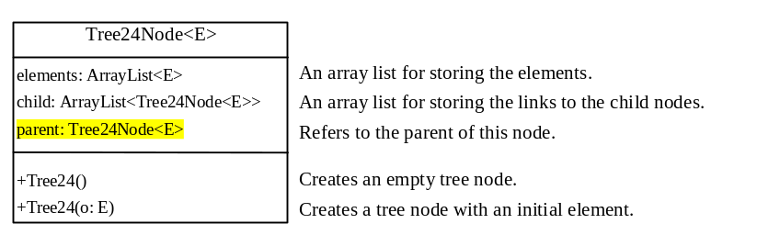

Add the following two new methods in Tree24:

public Tree24Node<E> getParent(Tree24Node<E> node)

Returns the parent for the specified node.

public ArrayList<Tree24Node<E>> getPath(Tree24Node<E> node)

Returns the path from the specified node to the root in an array list.

Write a test program that adds numbers 1, 2, ..., 100 to the tree and displays the paths for all leaf nodes.

47.7***
(The BTree class) Design and implement a class for B-trees.

